**Nadimpalli MaheshVarma**

**Email**:maheshvarma.n77 @gmail.com 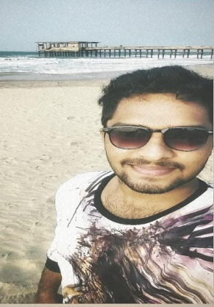

**Mobile**:8309777368

Dommeru, India

**CAREEROBJECTIVE:**

To secure a position in an esteemed organization where I can utilize and enhance my skills contributing to the organization’s growth.To get an opportunity to showcase my abilitiesdesiring company’s progress along with my career progress.

**ACADEMICPROFILE:**

|  |  |  |  |  |
| --- | --- | --- | --- | --- |
| **Qualification** | **College**  **/School** | **Board**  **/University** | **Year of Study** | **CGPA/Percentage**  **(%) as of now** |
| **B.Tech in**  **Computer science**  **andEngineering**  **(C.S.E)** | Godavari Institute of  Engineering & Technology  (Autonomous),Rajahmundry | Permanent affiliation to JNTUK | 2019  -2023 | 8.42(till date) |
| **Intermediate (M.P.C)** | Tirumala Junior College,rajahmundry | Boardof  Intermediate  Education | 2017  -2019 | 98.00% |
| **S.S.C** | Tirumal high scholl | Board of  Secondary  Education | 2017 | 97.00% |

**ACHIEVEMENTS:**

⮚ Completed a course on Java Programming: Solving Problems with Software in

Coursera (2021)

⮚ Completed a course on Python in Spoken Tutorial (2021)

⮚ Completed a course on SQL(Basic) in Hacker Rank (2021)

⮚ Attendedworkshop regarding Django practice using python by

APSSDC

**PROGRAMMING SKILLS:**

⮚Programming : C, Python, C++, Java

⮚ Database : SQL

⮚ Scripting : Java Script, HTML

**PROJECTS:**

⮚ Worked on Design Thinking and Innovationprojecttitled**"Smart Voting System**

**Support Through Face Recognition"**

**LANGUAGES KNOWN:**

⮚English

⮚Telugu

**STRENGTHS:**

⮚ Patient and Quick Learner

⮚Optimistic in nature

⮚ Intense Observer

**INTERESTS:**

⮚ Improving my Technical Skills

⮚ Software Development

⮚ Exploring new things

**DECLARATION:**

I here by **declare** that the information furnished above is true to the best of my knowledge.

(N.MaheshVarma)